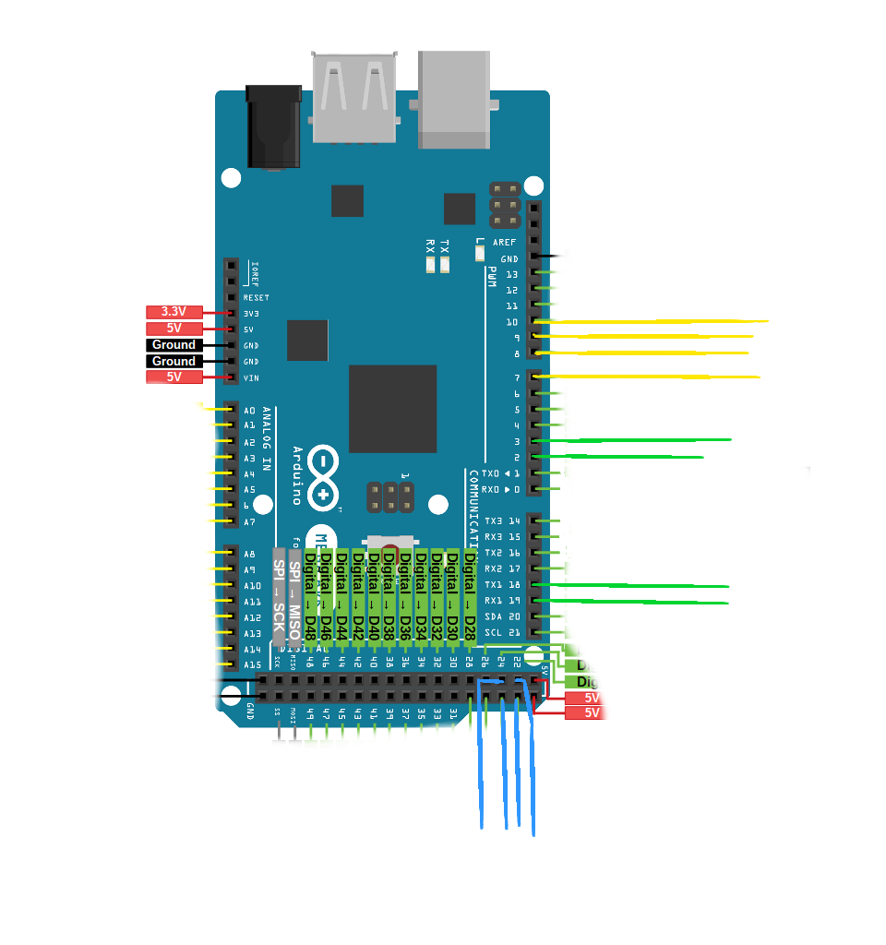
Motor 2 PWM Pin
Motor 3 PWM Pin
Motor 1 PWM Pin
Motor 4 PWM Pin
Motor 3 encoder B Pin
Motor 4encoder B Pin

Motor 1 encoder B Pin
Motor 2 encoder B Pin

Motor 2 encoder A Pin
Motor 1 encoder A Pin
Motor 3 encoder A Pin
Motor 4 encoder A Pin

